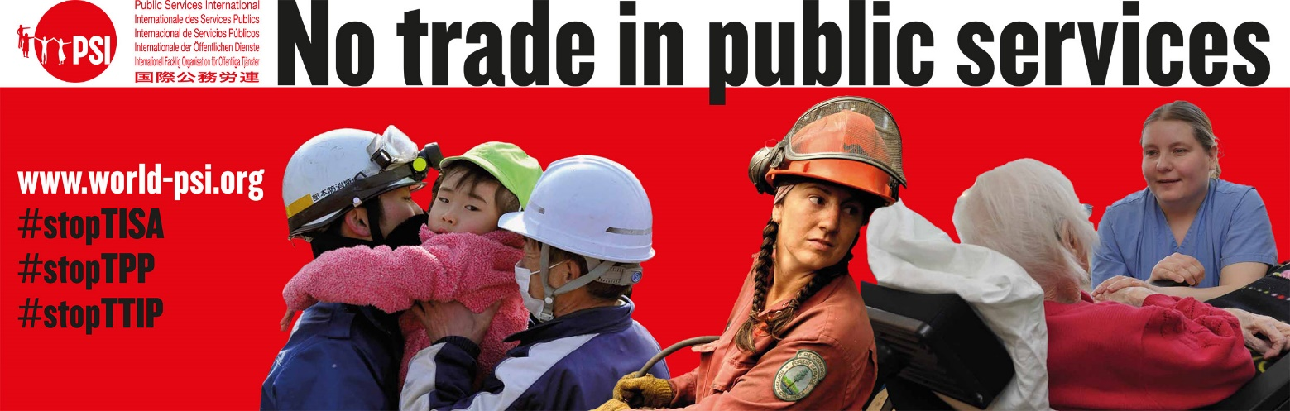

STRICTLY EMBARGOED – not for publication or distribution until 28 APRIL 2014

Secret negotiations threaten public services in 50 countries
Trade in Services Agreement will make it easier for corporations to profit with impunity

Members of civil society took to the streets today in a number of countries around the world to protest against the Trade in Services Agreement (TISA) secret negotiations resuming in Geneva, Switzerland.

Users of public services and public service workers are demanding the release of more information on this sweeping trade deal, and assurance that it will not affect provision of any public services. They are also delivering to government leaders a protest letter signed by over 350 organisations from over 115 countries.

Speaking from the lead protest in Geneva today, Rosa Pavanelli, General Secretary of Public Services International (PSI), said: “This is an attempt to secretly extend the most damaging parts of the infamous GATS agreement that previously sparked global protests. The aim of public services should not be to make profits for large multinational corporations. Ensuring that failed privatisations can never be reversed is free market ideology gone mad.”

Pavanelli emphasizes that, “It is fundamentally undemocratic for parliaments to permanently hand over the people’s democratic mandate to multinational companies.”

In [insert your country], a representative for [insert name/title/union] said: “Our government must immediately release the text it is negotiating so that members of the public can understand the potential effects on our everyday lives.”

The first study to examine these secret negotiations has found that the agreement could hinder future governments from delivering vital public services. This could include [insert a local example of impact on health or child care, power, water, postal service, etc.]

In the new report “TISA versus Public Services,” researchers highlight how the Trade in Services Agreement would lock in existing and any future privatisation of public services. The proposed agreement could make it impossible for future governments to restore public services to public control, even in cases where private service delivery has failed. It would also restrict a government’s ability to regulate key sectors including financial, energy, telecommunications and cross-border data flows.

In Brussels, Jan Willem Goudriaan, Deputy General Secretary of the European Federation of Public Service Unions (EPSU), said: “This agreement will bind future governments, regardless of who wins elections and what the courts say. If the European Commission has nothing to hide they must immediately release full details of these negotiations.”

In London, Dave Prentis, General Secretary of UNISON, spoke of people’s experience in the United Kingdom: “Privatisations of the National Health Service and the London Underground transit system have been costly disasters. Tying our government’s hands to prevent us from dealing with failed privatisations will give business the green light to take us all for an expensive ride.”

The report was written by Scott Sinclair, Canadian Centre for Policy Alternatives, and Hadrian Mertins-Kirkwood, Institute of Political Economy, Carleton University.

Download the “TISA versus Public Services” report at: www.world-psi.org/TISA

END

For more information contact: [insert name/email/telephone]

